Mock-up Pages- Task 4

Mock-up 1

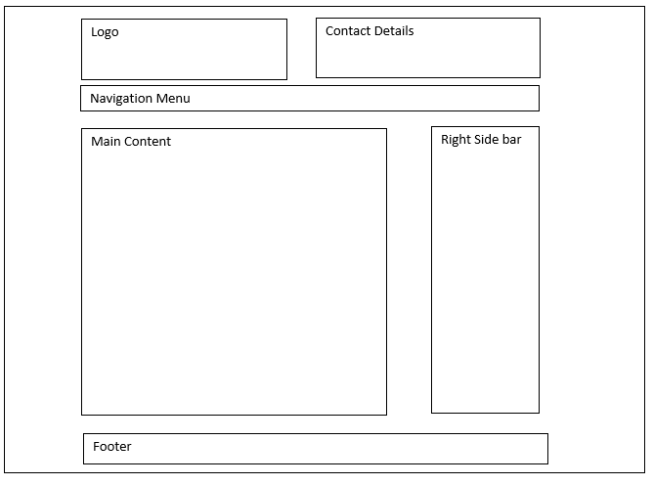

This mock-up of the website for AllStyle Homes would be recommended because the easiest to look at because you can look at all information on the screen without having to look from one side to the other just to get the information that someone would be looking for. The navigation system that would be recommended would linear navigation because there is enough information in the site to put all the pages on the one line of navigation.

Mock-up 2

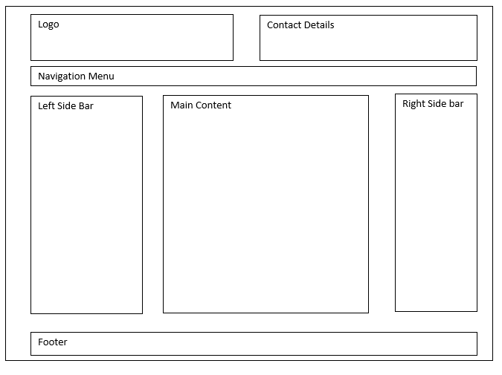

This mock-up of the website for AllStyle Homes would be a bit more complex to look at because there is information all across the screen, but there is more room on this mock-up compared to the first one, and there is room for a gallery on one of the side bars. We recommend that the linear navigation system be used, but we can make it a hierarchical and make a new labelling system to fit a drop down menu by grouping pages under the same category.

Mock-up 3

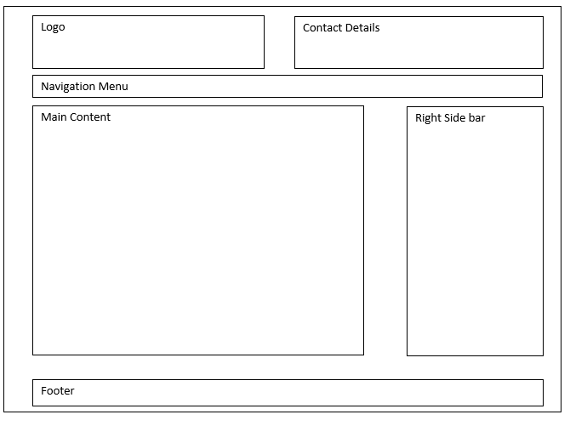

This mock-up of the website for AllStyle Homes is similar to the first mock-up, just spread out over most of the screen, meaning that someone looking at the site would have to look from left to right to get all the information presented on the website. We recommend that the linear navigation system be used, we can also make the website a global navigation system, they are the most complex navigation systems to make, but they are the most flexible in a website.